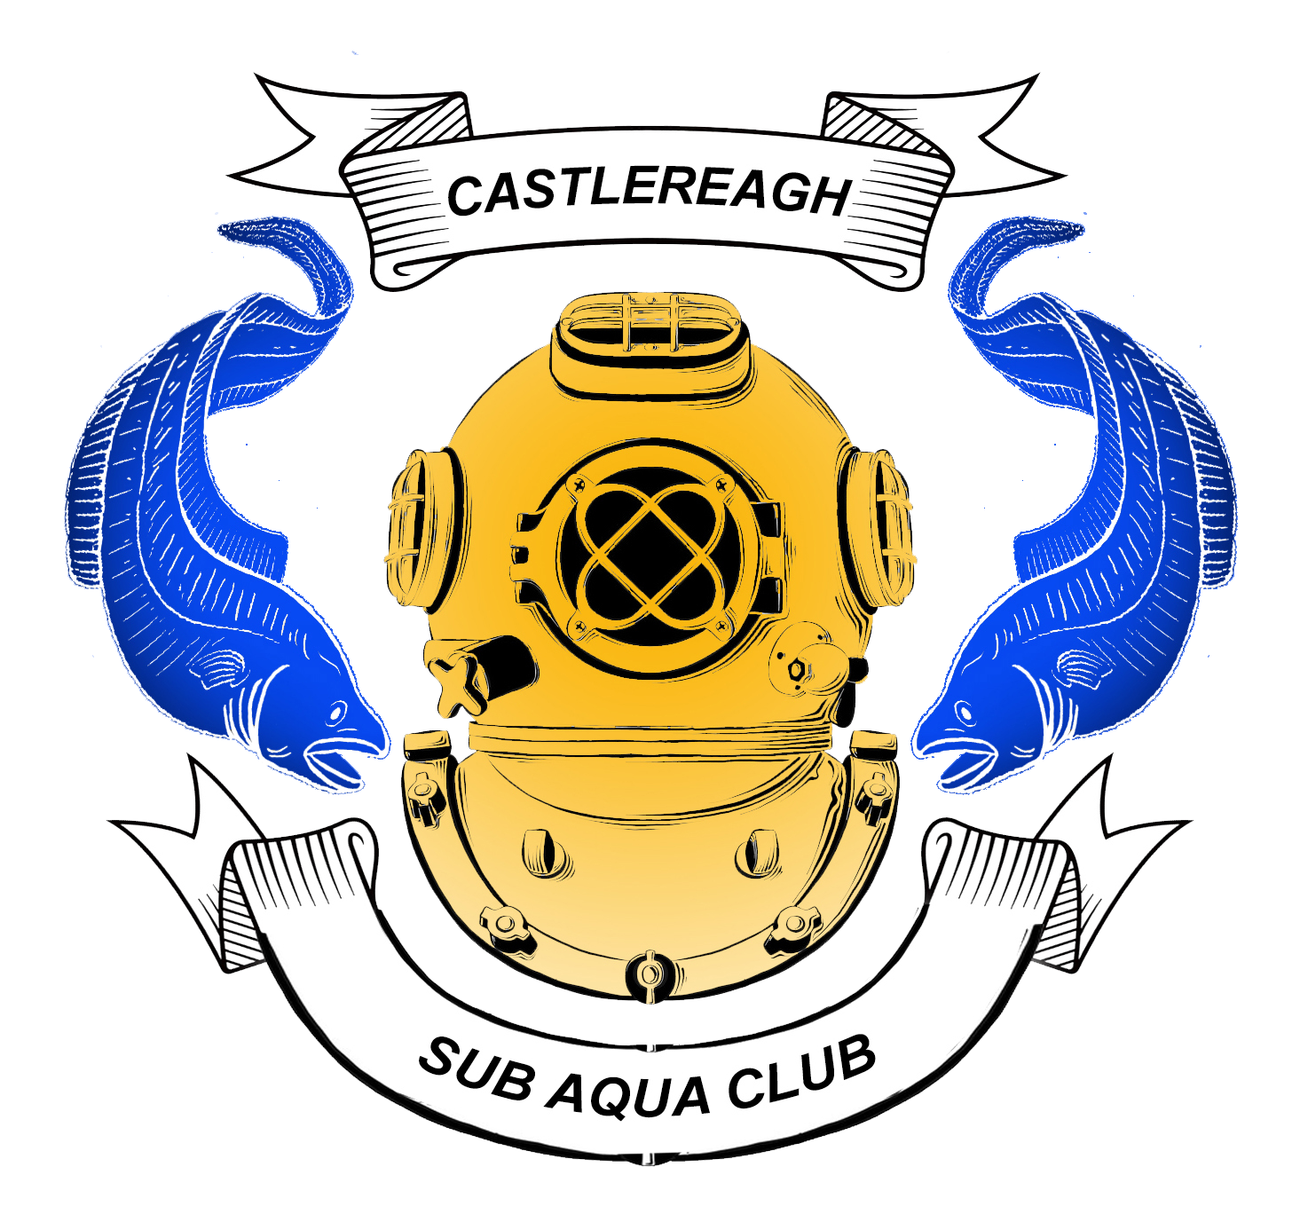
Risk Assessment Form

Castlereagh Sub Aqua Club

Club (branch) …………………………………………………… Location ……………………………………… Date…………………

Hazard | Who | Frequency  * | Severity  * | Risk evaluation | Controls | Immediate measures to deal with consequences if risk does occur
Heart attack | All | Rare | Fatal | Medium | Medical self-declaration / referral to Medical Referee. | BLS by Instructor.  Emergency services activation plan.
Ear damage | All | Occasional | Moderate injury | Medium | Trainees receive specific instruction in ‘ear clearing’.  Divers or snorkelers do not dive when suffering from a cold. | Assistance from Instructor or buddy.
Mask Squeeze | Trainees | Rare | Minor injury | Low | Only mask which encloses both eyes and nose in the same airspace used.  Trainees receive specific instruction in mask equalisation. | Assistance from Instructor or buddy.
Injury from falling cylinders | Trainees | Rare | Moderate injury | Low | Trainees taught to always lay heavy equipment down.  Monitoring by Instructor. | First Aid by Instructor.
Running out of air | All divers | Occasional | Fatal | High | All SCUBA sets fitted with cylinder pressure gauges.  Monitoring by Instructor.  Instructor / trainee ratios in accordance with BSAC recommendations. | All divers carry AS.
Rapid ascent | All divers | Occasional | Fatal | High | Progressive training.  Correct weighting of all divers.  Monitoring by Instructor.  Instructor / trainee ratios in accordance with BSAC recommendations.  Visual datum used for ascent exercises where appropriate. | Diving monitored by shore / boat cover able to provide / direct assistance.  Oxygen Administration equipment and trained administrators on site.
Entanglement in nets/lines/under-water obstructions | All divers | Rare | Fatal | Medium | All divers carry appropriate cutting implement, such as filament line cutter, wire snips, diving knife, etc.  Instructor control. | Assistance from buddy
Diver Separation | All Divers | Occasional | Fatal | High | Divers to dive in buddy pairs at all times.  Contact to be maintained throughout the dive.  Strobes or buddy lines to be carried. | Divers to surface immediately. Re-establish contact.  Render assistance as required.  Apply first aid or hospitalise as required.
Reduced underwater visibility | All Divers | Frequent | Major Injury | High | Diver numbers in water to be controlled and monitored.  Divers to carry strobes and buddy lines on all dives. | Strobes & buddy lines items to be used in the event of the onset of reduced visibility.  Dive to be abandoned in the event of adverse reduced visibility.  Divers to surface and exit.  Dive Manager to abort diving.
Trips/Slips & Tumbles | All | Occasional | Minor Injury | Low | Dive Manager to advise all divers of no running on site.  Make party aware of road-mounted ringbolts and other dangers. | Remove casualty from danger and provide appropriate first aid.  Hospitalise, as required.
Decompression illness | All divers | Occasional | Major  injury | Medium | Dives planned and conducted in accordance with BSAC ‘88 Decompression Tables or decompression computer.  All divers equipped with depth gauges and watches and / or decompression computers. | Oxygen Administration equipment and trained administrators on site.
Nitrogen Narcosis | All divers | Frequent | Fatal | High | Progressive build-up of depth experience for trainees.  Progressive work-up dives for all divers who are going beyond their recent diving experience.  Experience gained in company of Instructor / diver of greater experience at that depth.  Clear dive plans. | Assistance from Instructor / buddy.
Separation from boat while drift diving | All divers | Occasional | Fatal | High | Dive plan agreed with boat Coxswain.  All dive pairs follow same plan.  All dive pairs marked by Surface Marker Buoy. | Each diver carries aids to visual detection – e.g. flags, sausage buoys, strobes, flares, whistles etc.
Contact with dive boat / propeller | All divers | Rare | Fatal | Medium | Only trained coxswains allowed to operate boats.  Trainees receive specific instruction in boat exit / entry techniques.  All exit from and entry to boats controlled by coxswain. | First Aid kit on boat.  Boat crew trained in First Aid.
Injury from other boats | All divers | Rare | Fatal | Low | Flag ‘Alpha’ flown while divers are underwater.  Monitoring of other surface traffic by boat cover.  Divers marked by SMBs or ascending under DSMBs. | First Aid kit on boat.  Boat crew trained in First Aid.
Deteriorating weather | All divers | Frequent | Fatal | High | Diving planned using latest weather information.  Alternative site planned.  Weather conditions constantly monitored by Dive Manager / coxswain during diving.  Diver recall mechanism available (e.g. signals via SMB line, Thunder flashes) | Diving cancelled or changed to back-up site by Dive Manager.  Diving in progress terminated using diver recall mechanism.  Boat intentions and appropriate times notified to Coastguard prior to departure. Updated if plans are changed.

Assessed by:

Name………………………………………………………… Position……………………………………………. Date…………………

